FINAL PROJECT REPORT

Date | 27 June 2024
Team ID | SWTID1720428909
Project Title | Vitamin Vision: Unveiling the Spectrum of Nutrient Detection

- Project Initialization and Planning Phase:
  - Initialization: The project objective was to develop a machine learning model for accurate vitamin detection. Key methods and technologies were chosen, including Python, Exploratory Data Analysis (EDA), Data Preprocessing Techniques, Regression Algorithms, Classification Algorithms, Deep Learning, and Web App development.
  - Planning: Tasks were divided among team members using the Jira platform, ensuring clear responsibilities and timelines for efficient project management.

Data Collection and Preprocessing Phase:
  - Data Collection: The dataset was obtained from the Kaggle platform, specifically the file named "vitamin-detection."
  - Preprocessing: Data preprocessing involved several techniques such as resizing, data augmentation, normalization, denoising, edge detection, and color space conversion. These steps were crucial for preparing the data for model training and ensuring robust and accurate results.

Model Development Phase:
  - Model Selection: The development phase included comparing two CNN models, VGG19 and VGG16, to determine the more suitable model for the task. The models were evaluated based on their performance in detecting vitamins from the preprocessed images.

- Testing: Extensive testing was conducted to achieve the highest accuracy, ultimately selecting the better-performing model for final implementation.

Model Optimization and Tuning Phase:
  - Hyperparameter Tuning: The chosen model underwent fine-tuning of hyperparameters to optimize its performance. This phase involved experimenting with different settings to achieve the highest possible accuracy and ensure the model's reliability in real-world applications.

Advantages and Disadvantages:
  - Advantages:
    - High Accuracy: The VGG19 model's deep architecture enables detailed feature extraction, leading to high accuracy in vitamin detection.
    - Pre-trained Weights: Availability of pre-trained weights on large datasets like ImageNet facilitates transfer learning and speeds up model development.
    - Balanced Complexity: VGG19 offers a good balance between model complexity and computational efficiency, making it feasible for projects with limited resources.

Disadvantages:
    - Computational Demand: Despite being manageable, VGG19 still requires significant computational resources compared to simpler models.
    - Overfitting Risk: The deep architecture can lead to overfitting if not properly regularized or if the dataset is not large enough.

Final Project Summary:
The "Vitamin Vision" project successfully developed a machine learning model using VGG19 to accurately detect and quantify vitamins from image data. Through meticulous data preprocessing, model comparison, and hyperparameter tuning, the project achieved high accuracy and demonstrated the effectiveness of deep

learning in nutritional assessment. The project not only highlights the potential of advanced analytical techniques in healthcare but also provides a robust framework for future research and practical applications in vitamin detection and health monitoring.

Github and Project demonstration Links:
-Github Link: https://github.com/ADARSH-SINGH-1/VitaminVision.git
-Video Link: https://drive.google.com/file/d/1mZFEKivWoi6pgq- AWurcvPLjMGCKKwnC/view?usp=sharing
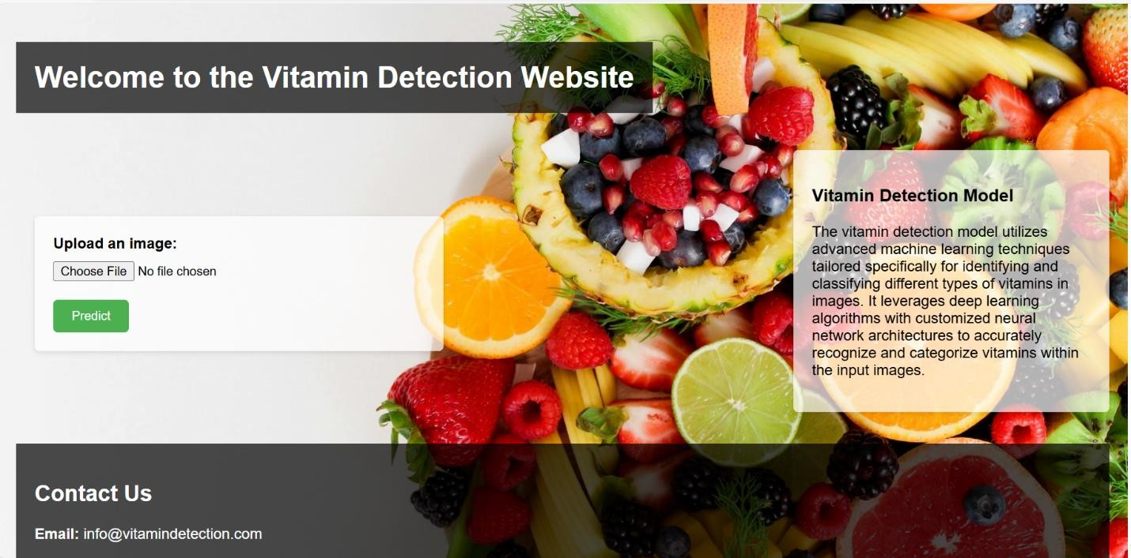

- Website screenshots:

